**Environmental Monitoring**

**Project Overview:**

Provide a brief overview of the project, including its goals, objectives, and the importance of environmental monitoring through IoT.

**Project Scope:**

Define the boundaries of the project, including what will be included and what will not be included.

**Project Team:**

List the members of the project team, including their roles and responsibilities.

**Technology Stack:**

Outline the web development technologies and IoT technologies you plan to use in the project. This may include languages, frameworks, hardware components, and software tools.

**System Architecture:**

Provide a high-level overview of the system's architecture. This should include components like sensors, microcontrollers, data storage, and the web platform.

**Environmental Parameters to Monitor:**

List the environmental parameters that your IoT system will monitor. For example, temperature, humidity, air quality, soil moisture, etc.

**Hardware and Software Components:**

Detail the specific hardware and software components you will use for data collection, processing, and storage.

**Data Flow:**

Explain the flow of data from the sensors to the cloud platform and how data will be processed and stored.

**Web Platform Development:**

Describe the web platform you will develop. Include details about its functionalities, features, and the technologies you'll use for web development.

**User Interface (UI):**

Provide information on the design and layout of the user interface, including any mockups or wireframes if available.

**Data Visualization:**

Explain how data will be visualized on the platform, including charts, graphs, and real-time updates.

**Data Storage:**

Describe how and where data will be stored, whether in a database, cloud storage, or other means.

**Data Security:**

Explain the security measures in place to protect data, including encryption and access control.

**Alerts and Notifications:**

Detail how users will receive alerts or notifications based on the environmental data, such as email alerts or mobile app notifications.

**User Roles:**

Define different user roles and their access privileges within the web platform.

**Testing and Quality Assurance:**

Explain the testing strategies and quality assurance measures that will be implemented during the project.

**Deployment Plan:**

Describe the plan for deploying the IoT devices, sensors, and web platform in the field.

**Maintenance and Support:**

Outline the plan for ongoing maintenance, updates, and support after the project is deployed.

**Timeline:**

Provide a project timeline that includes milestones and deadlines.

**Budget:**

Estimate the budget required for the project, including hardware costs, software licenses, and personnel expenses.

**Risks and Mitigations:**

Identify potential risks and the strategies you'll use to mitigate them.

**Conclusion:**

Summarize the key points of the document and highlight the project's significance.

**Appendices:**

Include any additional documents or references that are relevant to the project, such as technical specifications, code snippets, or diagrams.

**Mobile App Development:**

To connect your environmental monitoring IoT project with a mobile app, you'll need to establish a communication link between your IoT devices or sensors and the mobile app. Here are the steps to connect your IoT project to a mobile app

**Choose the Right Communication Protocol:**

You need to select a communication protocol that your IoT devices and the mobile app can both support. Some common protocols for IoT communication include MQTT, HTTP/HTTPS, CoAP, and WebSockets. Choose the one that fits your project's requirements.

**Set Up a Cloud Platform:**

It's often a good practice to have a cloud platform as an intermediary between your IoT devices and the mobile app. Cloud platforms like AWS IoT, Azure IoT Hub, or Google Cloud IoT Core provide the infrastructure to manage and process data from IoT devices.

**Device Registration and Authentication:**

Register your IoT devices on the cloud platform and set up authentication and security mechanisms. This typically involves generating API keys, certificates, or tokens to ensure secure communication.

**Data Ingestion:**

Configure the IoT devices to send data to the cloud platform using the chosen communication protocol. This data can include environmental parameters such as temperature, humidity, or air quality.

**Mobile App Development:**

* Choose the appropriate mobile app development platform (e.g., iOS, Android).
* Develop the mobile app with features for data visualization, user registration, and settings.
* Implement user authentication and security for the mobile app to access the IoT data.
* Integrate libraries or SDKs for communication with the cloud platform using the chosen protocol. Ensure secure communication.

**Real-time Data Display:**

Design the mobile app's user interface to display real-time data from your IoT devices. This could include charts, graphs, or numerical values that update as new data arrives.

**User Alerts and Notifications:**

Implement push notifications or in-app alerts to inform users of significant environmental changes or system events. These notifications can be triggered based on the data received from the IoT devices.

**User Registration and Management:**

Allow users to register and manage their accounts within the mobile app, including setting preferences and configuring alert thresholds.

**Testing and Debugging:**

Thoroughly test the mobile app to ensure that it can successfully communicate with the IoT devices and cloud platform. Debug any issues that arise during the testing phase.

**Deployment:**

Publish the mobile app on app stores (e.g., Apple App Store and Google Play Store) for users to download and install.

**User Training and Documentation:**

Provide users with training and documentation on how to use the mobile app and understand the environmental data it presents.

**Maintenance and Updates:**

Regularly maintain and update both the mobile app and the IoT devices' firmware to address bugs, add new features, and improve security.

**Monitoring and Analytics:**

Implement analytics and monitoring tools to track app usage and IoT device performance. This can help you identify issues and optimize the system.

For monitoring humidity and temperature, various IoT devices can be used, including:

1. **Temperature and Humidity Sensors:** These sensors measure temperature and humidity levels in the surrounding environment.

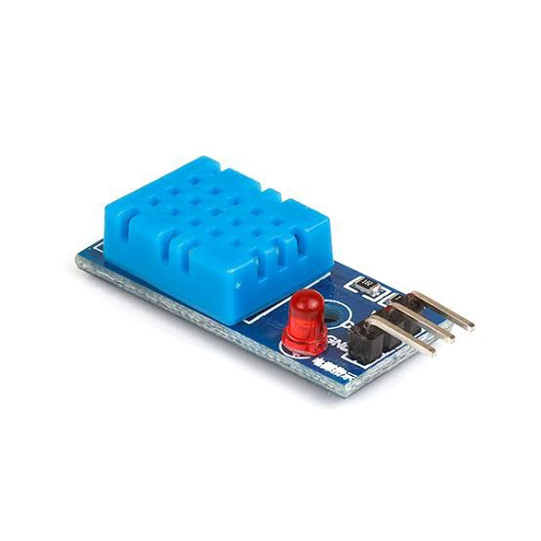

2. **Wireless Sensor Nodes:** These nodes facilitate the collection of data from the sensors and transmit it wirelessly to a central hub or cloud server.

1. 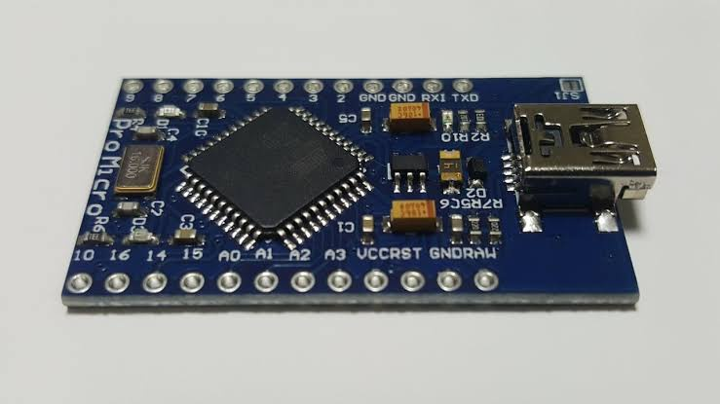**Microcontrollers:** Devices like Arduino or Raspberry Pi can be used to control and manage the sensors, facilitating data collection and transmission.

4. **Gateways or Routers:** These devices enable communication between the IoT sensors and the central network, facilitating data transfer and analysis.

5. **Cloud Platforms:** Cloud platforms provide the infrastructure to store, manage, and analyze the collected data, allowing for remote access and real-time monitoring.

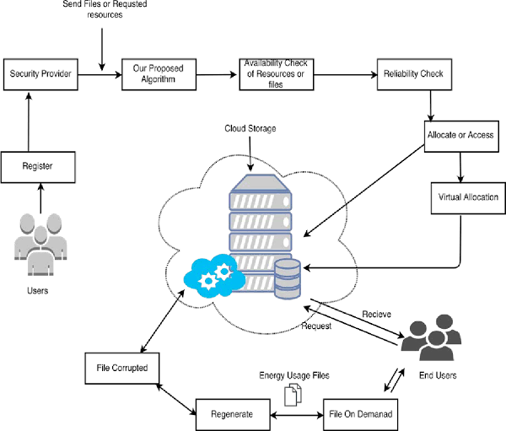

By combining these devices, a comprehensive IoT system can be set up for efficient and effective environmental monitoring of temperature and humidity.

Code implementation for environmental monitoring typically involves the following steps:

1. **Sensor Data Collection:** Writing code to read data from the environmental sensors, such as temperature sensors, humidity sensors, or air quality sensors.
2. **Data Transmission:** Implementing protocols like MQTT or HTTP to transmit the collected sensor data to a central server or cloud platform for storage and analysis.
3. **Data Storage:** Developing code to store the received data in a structured database, ensuring data integrity and efficient retrieval for further analysis.
4. **Real-time Analysis:** Creating algorithms or utilizing existing libraries to analyze the collected data in real-time, enabling the identification of patterns, anomalies, or trends in the environmental parameters.
5. **Data Visualization:** Generating code to create visual representations of the data, such as graphs, charts, or maps, to provide users with a clear understanding of the environmental conditions and trends.
6. **Alerting and Control Systems:** Implementing code to trigger alerts or notifications based on predefined thresholds and to enable remote control of environmental parameters if necessary.

By effectively implementing these code components, developers can create a robust environmental monitoring system that ensures the efficient collection, analysis, and visualization of data, enabling effective environmental management and decision-making.

**Program:**

Creating a Python program for an environmental monitoring IoT project that connects to a mobile app involves several steps. I'll provide an example Python code snippet for a simplified scenario to get you started. This example assumes you have a cloud-based IoT platform for data storage and retrieval. You can adapt this code to your specific project requirements.

**Code:**

**import paho.mqtt.client as mqtt**

**import json**

**# MQTT configuration**

**mqtt_broker = "your-mqtt-broker.com"**

**mqtt_port = 1883**

**mqtt_topic = "environmental_data"**

**# Replace with your authentication credentials**

**username = "your_username"**

**password = "your_password"**

**# Create an MQTT client**

**client = mqtt.Client()**

**client.username_pw_set(username, password)**

**# Callback function when connected to MQTT broker**

**def on_connect(client, userdata, flags, rc):**

**print("Connected to MQTT Broker with result code " + str(rc))**

**# Subscribe to the topic**

**client.subscribe(mqtt_topic)**

**# Callback function when a message is received**

**def on_message(client, userdata, msg):**

**payload = json.loads(msg.payload.decode())**

**# Process the received data**

**temperature = payload["temperature"]**

**humidity = payload["humidity"]**

**air_quality = payload["air_quality"]**

**# You can process the data further or send it to the mobile app**

**# Set callback functions**

**client.on_connect = on_connect**

**client.on_message = on_message**

**# Connect to MQTT broker**

**client.connect(mqtt_broker, mqtt_port, 60)**

**# Start the MQTT client loop**

**client.loop_start()**

**# Your code to send data to the mobile app**

**# You can use a library like Flask to create a REST API or use a WebSocket library to send data in real-time.**

**# In a real-world scenario, you would have additional logic to process and send data to the mobile app.**

**# Keep the script running**

**try:**

**while True:**

**pass**

**except KeyboardInterrupt:**

**client.disconnect()**

**print("Disconnected from MQTT Broker")**

**In this Python script:**

1. We use the paho-mqtt library to create an MQTT client to communicate with your IoT devices.
2. Replace the placeholders like your-mqtt-broker.com, username, and password with your specific MQTT broker and authentication details.
3. The on_connect function is called when the script successfully connects to the MQTT broker. It subscribes to the environmental_data topic, where your IoT devices send data.
4. The on_message function is called when a message is received on the subscribed topic. It decodes the JSON data and processes it. You can adapt this function to handle the environmental data and send it to your mobile app.
5. The script sets the callback functions and connects to the MQTT broker.
6. The main loop keeps the script running to receive and process data from the MQTT broker.